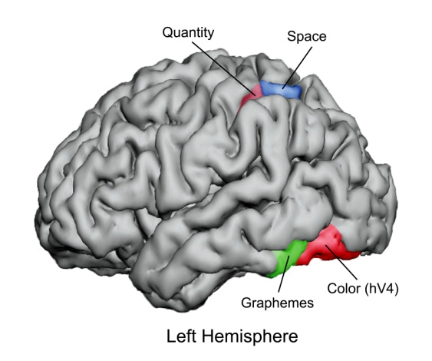
Case Western Reserve University

Presenting a two-part public program
Brain, Mind, and Behavior*

Keynote speaker:
Edward M. Hubbard
Vanderbilt University
April 16 – 17, 2010

Free and open to the public
Sponsored by the Department of Cognitive Science and the Department of Modern Languages and Literatures, of the College of Arts and Sciences, Undergraduate Student Government, and the Undergraduate Programming Board of Case Western Reserve University.

Free Public Lecture

Friday, April 16, 2010
Edward M. Hubbard
Synesthesia as Cross-Activation Between Brain Maps:
A Window into Human Nature
4:00 p.m. Lecture (Reception in lobby immediately following the program)
DeGrace Hall, Room 312, 2080 Adelbert Road, Cleveland

Visitor Parking (Adelbert Road): Rainbow-Babies Hospital Garage; Veale Center Garage

*N.B.: The “Language and Social Ontology” lecture by John R. Searle, originally scheduled for April 16, 2010, has been postponed. The program planners apologize for any inconvenience this may cause.

Synesthesia is a neurological condition in which stimulation of one sensory or cognitive pathway in the brain leads to automatic, involuntary experiences in a second sensory or cognitive pathway. For example, a synaesthete may experience perceiving specific colors when listening to music, or may see any given number as always tinged a certain color. The condition, first clearly documented by Francis Galton in 1880, faded from scientific awareness in the 20th century, however, there is renewed interest in area. Hubbard has demonstrated that synthetics were able to use their experiences of colors to enhance performance on visual tasks, and have increased activity in color selective regions of the brain. The neural model suggests that synesthesia may be a general feature of brain organization and may have implications for other cognitive domains as well. This work should be of interest to brain and behavioral scientists, cognitive scientists, mathematicians, musicians and musicologists, and artists and art historians. Far from being a mere curiosity, synesthesia may provide a widow into perception, thought and language.

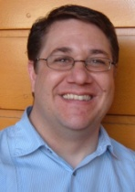
Edward M. Hubbard received a B.A. in Cognitive Science at the University of California, Berkeley, an M.A. in Experimental Psychology, and a Ph.D. in Psychology and Cognitive Science at the University of California, San Diego. His doctoral work included research at the Salk Institute for Biological Studies, where he conducted research on the perceptual and neural basis of synesthesia in collaboration with V.S. Ramachandran. His journal articles include: Hubbard, et al, “What information is critical to elicit interference in number-form synesthesia?” (Cortex), “The evolution of numerical cognition: From number neurons to linguistic quantifiers,” (Journal of Neuroscience), “Synaesthesia: The sounds of moving patterns,” (Current Biology), “A real red letter day,” (Nature Neuroscience). He currently is a post-doctoral fellow in the Department of Psychology and Human Development at Vanderbilt University.


(216) 368-8961 case.edu/artsci/

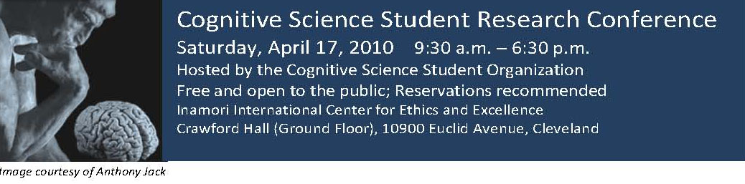
About the Conference
Conference registration deadline: Extended to April 13, 2010
To register, email: case.csso.conference@gmail.com
The Cognitive Science Student Organization (CSSO) of Case Western Reserve University is hosting an academic conference at which undergraduate and graduate students from any college or university may present their research from any discipline related to cognition. There is no conference registration fee, however, pre-registration is recommended by April 13, 2010. To register, email: case.csso.conference@gmail.com . Complimentary continental breakfast and dinner will be provided and snacks will be available throughout the conference.
Information: Click http://csso.case.edu, or email: Nicole Lord, Conference Coordinator (ndl7@case.edu)
Conference Schedule (subject to change):
9:30 – 10:00 a.m. Check-in, continental breakfast, and coffee
10:00 - 10:30 Introductory Remarks
10:30 – 11:30 Block I: R. Hudson, The Cognitive Neuroscience of Attachmen: Functional Imaging of Capgras Delusion;
R. Seo, Spatial and Temporal Cues in Statistical Cross-Situational Learning;
J. Amick, Uneasy Lies the Hand: Deception Associated with Increased Gesture Rate
11:30 – 12:00pm Coffee Break
12:00 – 1:20 Block II: R. Bhatia, ERP Correlates of Reward Magnitude and Valence Predict Future Decisions;
R. Gans, Empathy, Rationality, and Legal Judgment;
M. Elliot, Human Computer Interaction and Dexis: Understanding Spacial Grammar;
S. Ahmed, The Violent Search for God: A ‘Neuropsychoanalytic’ Examination of Religious Terrorism
1:20 – 1:50 Discussion
1:50 – 3:00 Lunch Break (on your own)
**3:00 – 4:00 Plenary address: Edward M. Hubbard (Vanderbilt University), Number Lines: From Synesthia to Education and Back
4:00 – 4:30 Discussion
4:30 – 5:00 Coffee Break
5:00 – 6:20 Block III: K. Saad, Trans-saccadic Integration of Visual Hallucinations Simulated by Extended Wilson-Cowan Equations
B. Shaw, The Meaning of Meaning
K. Begany, Social vs. Mechanical Reasoning
A. Subramanian, Gesture at the Crux of Communication Across Time and Culture
6:30 Dinner and Dessert

** N.B.: The keynote address by John R. Searle, originally scheduled for April 17th, has been postponed.

Visitor Parking: Visitor Central Garage (below Severance Hall, entrance on East Boulevard); Rainbow-Babies Garage (Adelbert Road), Veale Convocation Garage (Adelbert Road)

(216) 368-8961 case.edu/artsci/

