Travel Scholarship to the 4th Annual Cancer Disparities Symposium

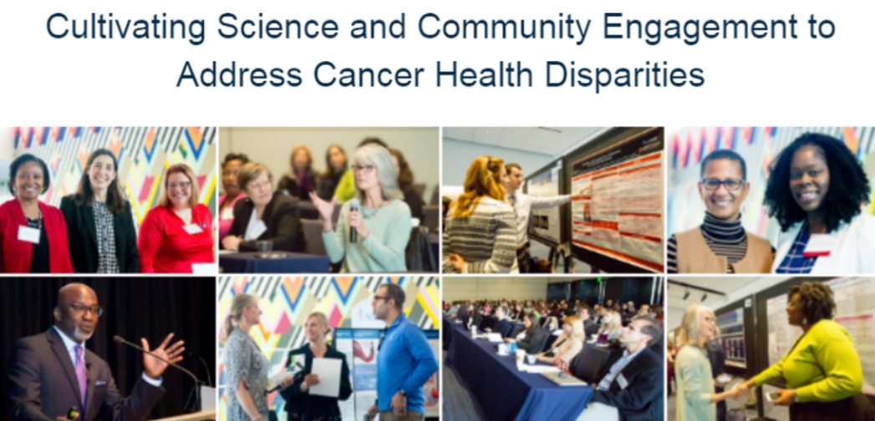

Case Comprehensive Cancer Center

March 6, 2020 Tinkham Veale University Center, CWRU Campus

Cleveland, Ohio

___________________________________________________________________

**APPLICATION FORM IS AT THE END OF THIS DOCUMENT**

Purpose
The purpose of the Travel Scholarship program is to promote professional development, diversity, and inclusivity among investigators and community organizations interested in cancer-related disparities research, by:

- Providing travel support to attend the 4th Annual Cancer Disparities Symposium
- Promoting collaboration and interdisciplinary networking at the symposium

* Up to four travel scholarships will be awarded.

Presentation topics may include, but are not limited to:

- Access to care
- Biological mechanisms
- Cancer prevention (e.g., risk assessment, tobacco use, obesity, nutrition, physical activity, HPV vaccination, behavior change, wellness)
- Early detection and screening (e.g., mammograms, colorectal screenings, low dose CT for lung cancer, cervical screening, oral exams, prostate screenings)
- Genetics or Genomics
- Geospatial mapping studies
- Intervention studies or clinical trials
- Novel approaches to eliminate disparities or achieve cancer health equity
- Policy
- Social determinants (e.g., environmental, behavioral, sociocultural, and economic influences)
- Survivorship (e.g., quality of care, follow-up care, quality of life, family, overall survival)
- Other relevant topics

Eligibility Criteria and Expectations:
- Have an interest in cancer disparities-related research or community outreach.
- Post-doctoral trainee, student (graduate level or undergraduate) or staff (e.g., cancer center, healthcare system, non-profit community-based organization) at a United States institution. Due to the legal restrictions of the scholarship funds, only applicants from a United States-based institution are eligible.
- Live at least 50 miles outside of Cleveland, OH.
- Have an abstract accepted to the 4th Annual Cancer Disparities Symposium.

Receipt of Travel Scholarship
Terms of the scholarship include:

Airfare: All travelers must make reservations in advance of the meeting.
Lodging: We strongly recommend that travelers stay at the Marriott Courtyard Hotel.
Other travel expenses: Ground transportation, parking, meals
Conference registration fee

Application Components
1. Application Form: Please complete the form at the bottom of this document in its entirety.

2. Personal Statement: Please prepare a brief (150-250 words, max) statement, which describes the main research question that you would like to explore, or your current work in the area of community outreach, and career goals related to your work. Please include your name on your statement.

3. Resume/Curriculum Vitae/Biosketch

Please forward an electronic copy of your application materials to the Scholarship Subcommittee (caseccc-ocdr@case.edu).

Terms of Accepting the Travel Scholarship
Acceptance of a travel scholarship is contingent on the recipient having an abstract accepted to the 4th Annual Cancer Disparities Symposium for an oral or poster presentation and agreeing to attend the entire symposium.

Important Dates
- Applications due December 3, 2019 at 5pm, Eastern Standard Time
- Scholarship recipients will be notified by December 20, 2019
- Recipients must confirm their acceptance of the scholarship by January 2, 2020
- Travel arrangements (flight and hotel) must be completed by the Case CCC travel agent by January 18, 2020

Questions, please contact:

Scholarship Subcommittee
4th Annual Cancer Disparities Symposium
caseccc-ocdr@case.edu

4TH ANNUAL CANCER DISPARITIES SYMPOSIUM TRAVEL SCHOLARSHIP
Insert photo

Application
An electronic copy of your application must be received by 5pm Eastern Standard Time, December 3, 2019.
Please enter the information requested.

CONTACT INFORMATION
Name
(First, Middle, Last)

Professional Title

Mailing Address
Number and Street
City/Town
State
Zip Code

Phone Number

Email Address

APPLICANT BACKGROUND
Institution/
Department

Area of Research/or Practice
(brief keywords are fine)

Academic/Professional Degree(s)

Primary Mentor/ or Supervisor
Name
Email
Phone Number
For the following, please BOLD your responses.
Gender | Male | Non-binary or non-conforming
 | Female | Other (please specify):
 | Transgender
Race/Ethnicity  (indicate all that apply) | American Indian/Alaska Native |  | Latino/Hispanic
 | Asian/Pacific Islander |  | White
 | Black/African American |  | Other (please specify):

How did you learn about the Travel Scholarship? | Symposium email |  | Email from colleague
 | Word of mouth |  | Listserv
 | Other:
Have you previously attended the cancer disparities symposium? | Yes | No
Did you submit an abstract to the 4th Annual Meeting? | Yes | No
Abstract Title

APPLICATION CHECKLIST
Completed application form
A personal statement (maximum 250 words) which describes the main research question that you would like to explore or current practice and career goals. Please be as specific as possible.
Resume or curriculum vitae (CV)

I will commit to using funds to support travel to the symposium and participating in the entire event.

Applicant Signature: __________________________________________

Date: _________________

I support the submission of this travel scholarship application.

Mentor/Supervisor Signature: __________________________________________

Date: _________________

Please forward an electronic copy of your application materials to the Scholarship Subcommittee (caseccc-ocdr@case.edu).

