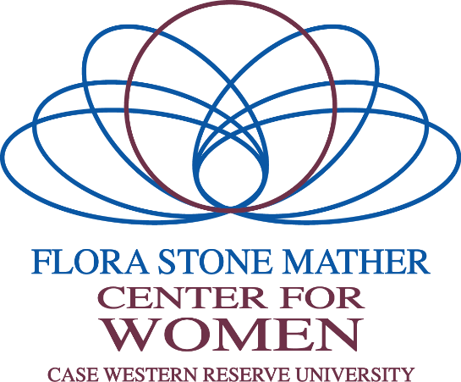

January 24, 2019

The Flora Stone Mather Center for Women and the Mather Spotlight Awards Selection Committee invite nominations of CWRU women faculty, staff, and students for the biennial Mather Spotlight Award. This award recognizes the achievements of two women from the faculty, two women from the staff, one graduate or professional student, and one undergraduate student whose outstanding professional accomplishments, leadership, and service have had a significant positive impact on our university and campus community. The Mather Spotlight Awards Selection Committee invites nominations by the Deans of each school, academic chairs, colleagues, and supervisors.

This year, the Flora Stone Mather Spotlight Awards will be presented at The Women of Achievement Awards Luncheon to be held Friday, November 1, 2019, from 12:30am - 2:00pm in the Tinkham Veale University Center.

For more information and criteria for nomination please see the nomination form below. The deadline for nominations is April 1, 2019.
Thank you for your continued support of women in our community and the Flora Stone Mather Center for Women. We look forward to a festive and celebratory event. If you have any questions, please contact me.
Best,

Lou Stark, Susan Freimark, M.A., L.P.C.
Vice President for Student Affairs Senior Associate Director
Flora Stone Mather Center for Women

The Flora Stone Mather Center for Women empowers all women and promotes gender equity and inclusion throughout the Case Western Reserve University community.

Women of Achievement 2019 Application
Thank you for taking the time and effort to nominate an accomplished woman for the Women of Achievement Award. All nominations will be reviewed by a committee that is comprised of a faculty member, a staff member, an undergraduate student, and a graduate or professional student which represents the categories being recognized. The criteria that will be evaluated for this award are:

- Professional Accomplishments (could include job performance, academic performance, scholarly contributions, etc.)
- Leadership
- Service (could include volunteering, teaching, committee work, mentoring, etc.)
- Demonstrated impact on our university/campus community

As you complete the nomination form, please bear in mind that the information you present is all the information the selection committee will have. Complete and thorough responses increase the success of the candidate’s nomination. Things to avoid in the nomination are repetition of facts and phrases such as “See above” and going beyond the character count.

For more information, contact Susan Freimark at sbf@case.edu or 216-368-8860.

Question 3 and 11 have drop down menus and form answers will be cut off at the designated character length. Please attach your nominee’s a resume or C.V.

- Name of Nominee
- Email of Nominee
- Nominee Category (Drop down menu.)
- Nominee Title and/or Rank
- Nominee Department, Program or Division
- How long have you known the nominee?
- Nominee’s Anticipated Degree (Leave blank if faculty or staff.)
- Department or Program Affiliation of Nominator
- Name of Nominator
- Email of Nominator
- Nominator Category (Drop down menu.)
- Number of years nominator has been in department or division?
- How long and in what capacity have you known the nominee? (1,500 characters)
- The mission of the Flora Stone Mather Center for Women is to empower all women and promote gender equity and inclusion throughout the Case Western Reserve University community. In what ways does the nominee reflect this mission? (2,500 characters)
- Please describe the professional and/or academic accomplishments of the nominee: (2,500 characters)
- Please describe the leadership and mentoring roles of the nominee: (2,500 characters)
- Please describe the nominee’s service to CWRU and/or the community. This may include volunteering, teaching, programming and policy initiatives, and community outreach: (2,500 characters)
- How has the nominee positively impacted CWRU? (2,500 characters)
- For student nominees: Is this student in good academic standing?
- Please provide your signature.

Please email this application to Elizabeth Smith, department assistant, at exs501@case.edu.

