How Women Decide
What’s True, What’s Not, and
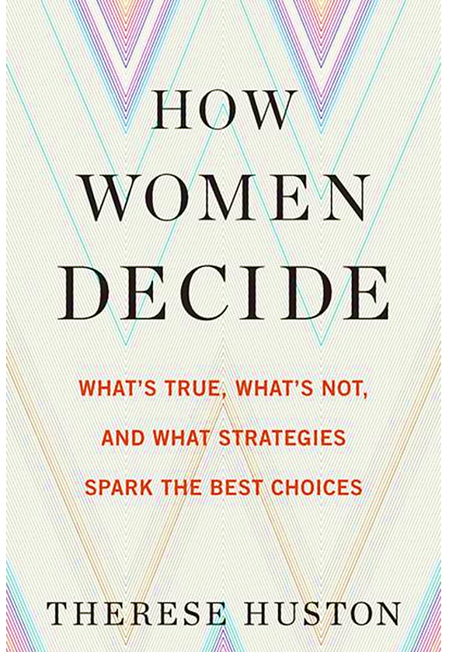
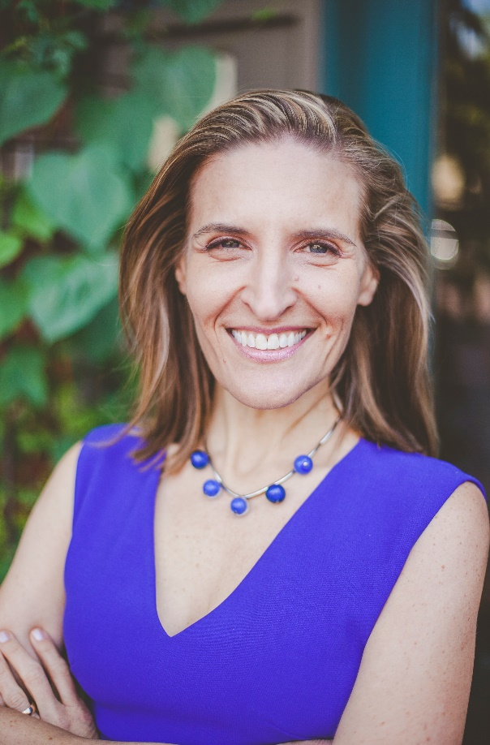
What Strategies Spark the Best Choices
“There’s an enormous double standard when it comes to how men and women are perceived as decision-makers, and those differences can hamper much more than a woman’s career.”
- New York Times Book Review, May 2016
Book Discussion with the author, Therese Huston

When: May 10, 2017, 6-6:30 PM Hors d'oeuvres & networking
6:30-8 PM Book presentation followed by open discussion
Where: Flora Stone Mather Center for Women
Tinkham Veale University Center Ballroom C (Note Room Change)
Parking: self-pay parking in P-29 parking garage on East Boulevard
Who can attend? Free and open to all
Please RSVP here: http://j.tinyurl.com/HowWomenDecide

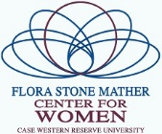
Sponsors:

