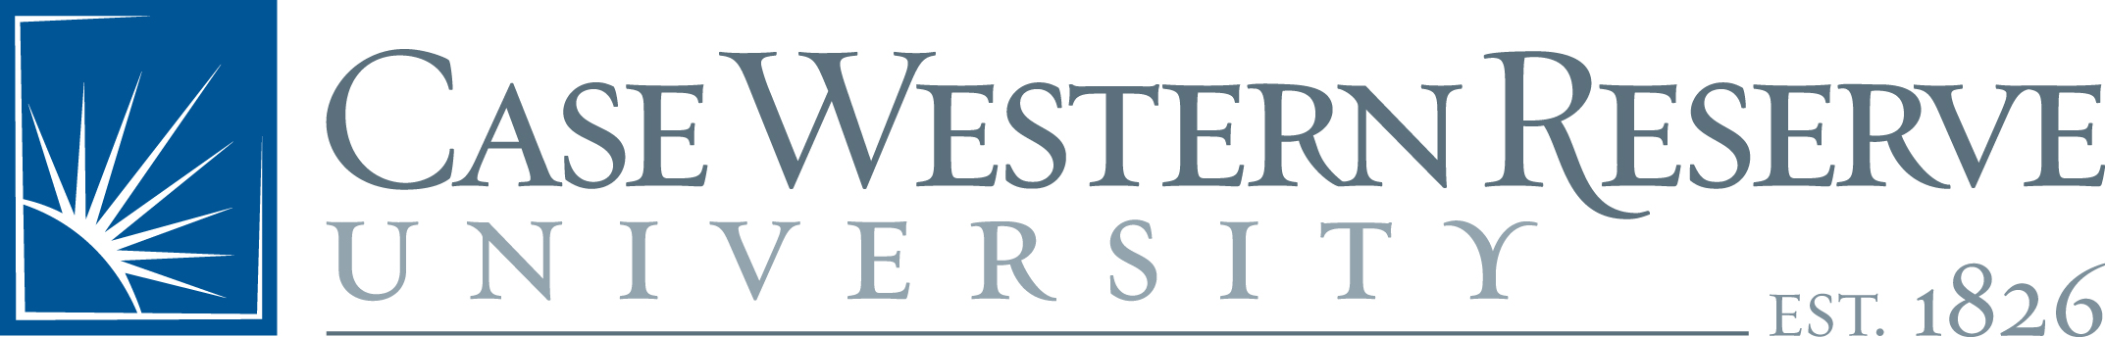

Institutions Developing Excellence in Academic Leadership-National (IDEAL-N)

Office of the Provost
Case Western Reserve University
10900 Euclid Avenue
Cleveland, Ohio 44106-7001
216.368.8874
http://www.case.edu/provost/ideal

IDEAL-N Partner Institution
Year One Change Project Report:
Please use as much space as necessary in each section

IDEAL-N Partner Institution:

Change Project Team Member Names:
Co-Director:
Change Leader:
Social Scientist:
Others:

Institutional Transformation Theme:

Institutional Transformation Vision:

Change Project Description:

Goals/Objectives of the Change Project:

Activities Undertaken:

Resources/Alliances Harnessed Across Campus:

Project Accomplishments/Findings:

Recommendations:

Sustainability Plans for Institutionalizing the Activities/Recommendations of the Change Project

Challenges Encountered or Likely:

Dissemination Activities and Plans:

