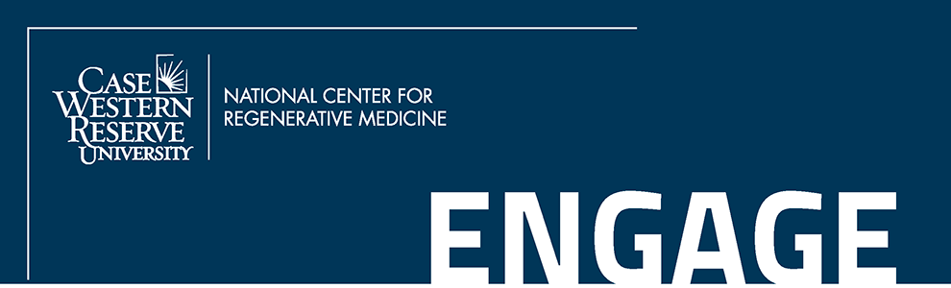

I. APPLICANT INFORMATION

Student Name
Last First

Email Address Phone Expected Graduation

Academic Institution

Academic Rank
Major Minor
Cumulative GPA

II. PROJECT INFORMATION

Project Title
Research Area of Focus Project Mentor

Project Start Date / / Project End Date / /

Expected number of hours per week to be spent on project

List all other summer project programs for which you have applied (e.g. SPUR, SOURCE, etc.).

III. PROJECT COMMITMENT

By signing below, the applicant and project mentor agree with the following statements, if the project is funded.

STUDENT COMMITMENT

- I agree to complete the proposed project as outlined in the submitted proposal.
- I agree to complete any required responsible conduct of research or safety training modules.
- I agree to attend department seminars to further develop understanding in the field.
- I agree to represent the ENGAGE program during the SOURCE Symposium and Poster Session.
- I agree to prepare a summary report explaining research efforts and outcomes (to include project abstract).
- I agree to acknowledge the support of this training grant in all posters and presentations that come from the work in this program by using the following statement:
“Supported by an ENGAGE research grant from the National Center for Regenerative Medicine.”

MENTOR COMMITMENT
- I, or my designee, agree to supervise and direct the student’s work.
- I, or my designee, agree to meet with the student on a weekly basis.
- I agree to match the award in the amount of $500.00 for research supplies.

Student Signature Date

Mentor Signature Date

Please submit your applications to damian.junk@case.edu as one pdf file consisting of:
1.) This completed and signed ENGAGE Application.
2.) Your current resume or curriculum vitae.
3.) Brief (1 page) summary of career goals and interest in stem cells and regenerative medicine research.
4.) Letter of support from project Mentor
5.) Project Proposal (2-3 pages) including:
- Project Title
- Project Overview
- Future implications for therapeutic discovery and/or patient care

