The Office of Diversity and Inclusive Excellence
Heightening Awareness and Building Sense of Community
irtVirtual Inclusive Talks and Lecture Series
2021 SUMMER VITALS

Health Disparities and Effects of COVID-19

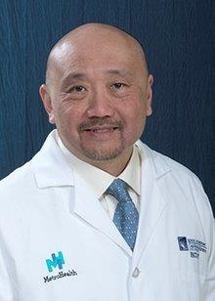
Dr. Ben Li, Edward G. Mansour Professor of Surgical Oncology
Case Western Reserve University
Medical Director, MetroHealth Cancer Center
"The Asian American and Pacific Islander Experiences of Racism during COVID-19"
Tuesday, June 29, 2021
7:00am to 7:45am
RSVP
(Ctrl + Left Click to follow link)
Join Zoom Meeting
ID: 95037739475
Passcode: 151233

Dr. Cynthia Kubu, Professor of Neurology,
Cleveland Clinic Lerner College of Medicine, Case Western Reserve University and Interim Vice Dean of Faculty, School of Medicine
"The Effects of COVID-19 on Women in the Academy"
Wednesday, July 21, 2021
5:00pm -5:45pm
RSVP
(Ctrl + Left Click to follow link)
Join Zoom Meeting
ID: 93116094238
Passcode: 619196

Dr. Monica Vela, Associate Dean of Multicultural Affairs, Pritzker School of Medicine, Associate Vice Chair for Diversity, and Inclusion, Department of Medicine, University of Chicago
"Health Disparities in Latinx and COVID-19”
Wednesday, August 25, 2021
12:00pm-12:45pm
RSVP
(Ctrl + Left Click to follow link)
Join Zoom Meeting
ID: 94714900001
Passcode: 274998

Tina Lining, Director of Diversity, and Inclusive Excellence, tar5@case.edu

