The Office of Diversity, Equity, and Inclusive Excellence
irtVirtual Inclusive Talks and Lecture Series
2021 FALL VITALS
Heightening Awareness and Building a Sense of Community

Honoring Hispanic Heritage Awareness
Margarita Diaz, MSN, RN
Director, Inclusion, Diversity, and Health Equity
The Office of Inclusion & Diversity/Human Resources
The MetroHealth System, Cleveland, Ohio
R.E.A.L
Race, Ethnicity, and Language
Wednesday, October 20, 2021
12:00pm - :00pm
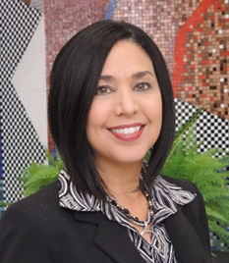
Click here to RSVP
Zoom

Honoring Native American Awareness
Jonathan Baines MD/PhD
Tlingit/Tsimshian
Medical Director Employee and Community Health Procedure Clinic
Instructor in Family Medicine, Mayo Clinic
“Native American Healthcare: Past, Present, and Future"
Wednesday, November 10, 2021
12:00pm - 1:00pm
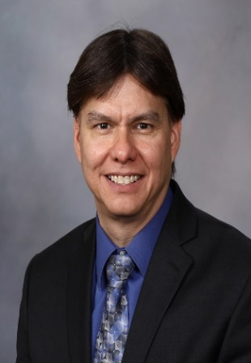
Click here to RSVP
Zoom

Dr. Arthur R. James, is a retired Obstetrician,
Gynecologist, and Pediatrician, Ohio State University Wexner Medical Center
"Health Disparities for Women of Color and Infant Mortality"
Wednesday, December 8, 2021
12:00pm -1:00pm
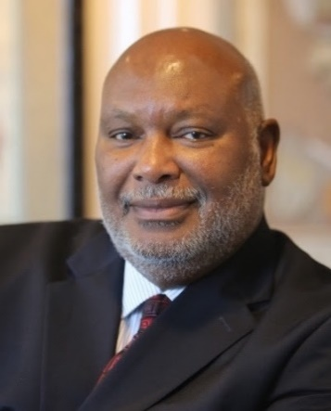
Click here to RSVP
Zoom

