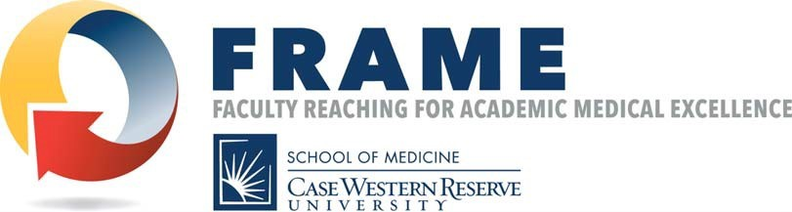

FRAME (Faculty Reaching for Academic Medical Excellence) is now being offered to all full time junior faculty (i.e., instructors, senior instructors and assistant professors). Women and minority faculty are strongly encouraged to apply. FRAME provides participants with: the tools and time for individualized career self-reflection, a list of campus resources to support one’s work, guidance and insights from university leaders, and the opportunity to build a cohort of colleagues within the School of Medicine. The program consists of seven half-day sessions, including two individualized one-hour coaching sessions with a Board Certified Coach. Class size will be limited to 25 participants per cohort. There is a $400 fee to participate in this program, paid by the participant or the department.
The curriculum includes activities in the following areas:
- Articulating your values and defining individual success
- Navigating and working within the culture of academic medicine
- Developing a career vision and career action plan
- Balancing work-life integration and maximizing effective time management to avoid burnout
- Learning best practices in networking, mentoring, sponsorship
- Identifying campus resources for working with students, honing presentation and teaching skills, and utilizing library resources
- Advancing your academic career (tenure-track and non-tenure track)
- Successfully managing an effective team (i.e., lab, project management)
- Developing research and grants management skills to ensure future success
- Working with diverse teams
- Understanding micro-aggressions and unconscious bias
- Improving your communication skills (e.g., writing)
- Mapping future steps on the leadership journey
Session Dates
Session I: Friday, August 26, 2022, 8:30am-12:00pm: Who You Are in the Larger Context
Session II: Friday, September 30, 2022, 8:30am-12:00pm: Defining Success and Developing a Plan
Session III: Friday, October 28, 2022, 8:30am-12:00pm: Connections, Internal and External
Session IV: Friday, December 2, 2022, 8:30am-12:00pm: Teaching and Presenting
Session V: Friday, January 27, 2023, 8:30am-12:00pm: Academic Advancement and Scholarship
Session VI: Friday, February 24, 2023, 8:30am-12:00pm: Teams and Inclusive Excellence
Session VII: Friday, March 24, 2023, 8:30am-12:00pm: Onward to the Future

Class size will be limited to 25 participants with an emphasis on diverse faculty with respect to gender, race, ethnicity, and institutions. Applications will be accepted through June 30, 2022. To apply for the program, please Click Here: https://bit.ly/383yjUa
For more information, contact Susan Freimark, Director of Faculty Development at sbf@case.edu.
Comments from the Class of 2022:
“I cannot thank you enough for giving me this opportunity. The days I participated I learned so much. I want more.”

“I had the opportunity to attend the FRAME program last year and I found it to be somewhat of an eye opener, in terms of being able to get a better vision of my goals and career path.

The organizing committee members have done a great job, with an impressive lineup of well renowned faculty members, who freely shared their experiences and advice for junior faculty members. The Q&A sessions at the end, were my favorite part.

It’s also a great opportunity to network and make connections.”

“This is my first experience with this type of workshop tailored to junior staff. I enjoyed it a lot, as the timing can’t be better. There was a lot of perceived work-related stress, not only from my own perspective but also from the group of participants. This workshop is very helpful in multiple ways. First, it taught us many practical tools that we can use for self-development and reinforced these concepts through the talks and discussions from the invited guests, who are established, physician leaders. Second, it created opportunities for us to reach out to peers and potential mentors. I benefit tremendously from these aspects, and I am very grateful.”
"I enjoyed participating in the FRAME program. It offered a unique opportunity to learn about varied career paths. There were many lectures about subjects that included career development, promotion, and mentorship. The breakout sessions allowed interaction with other clinicians who followed very different career paths and facilitated some interesting conversations. It was a thought provoking series of meetings. The virtual format worked surprisingly well."

