Interfolio Guide for Promotion Candidates

Step 1: Open Interfolio
Once you have submitted a declaration of candidacy for promotion to the Faculty Affairs office, a case will be created for you in Interfolio. When you receive notification that your case has been created, you can log on to Interfolio and start uploading the required documents.
Upon logging in, click the Case Western Reserve University logo and click the case that was created.
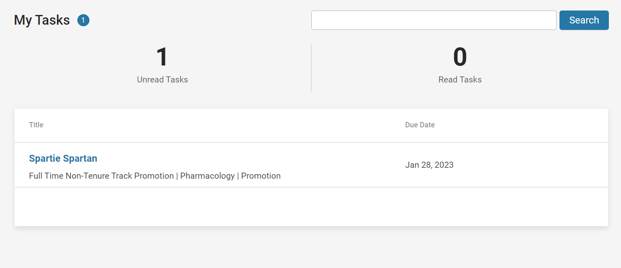

Step 2: Upload Required Documents
Next, Click “Packet” and “Expand All” to see all required documents.
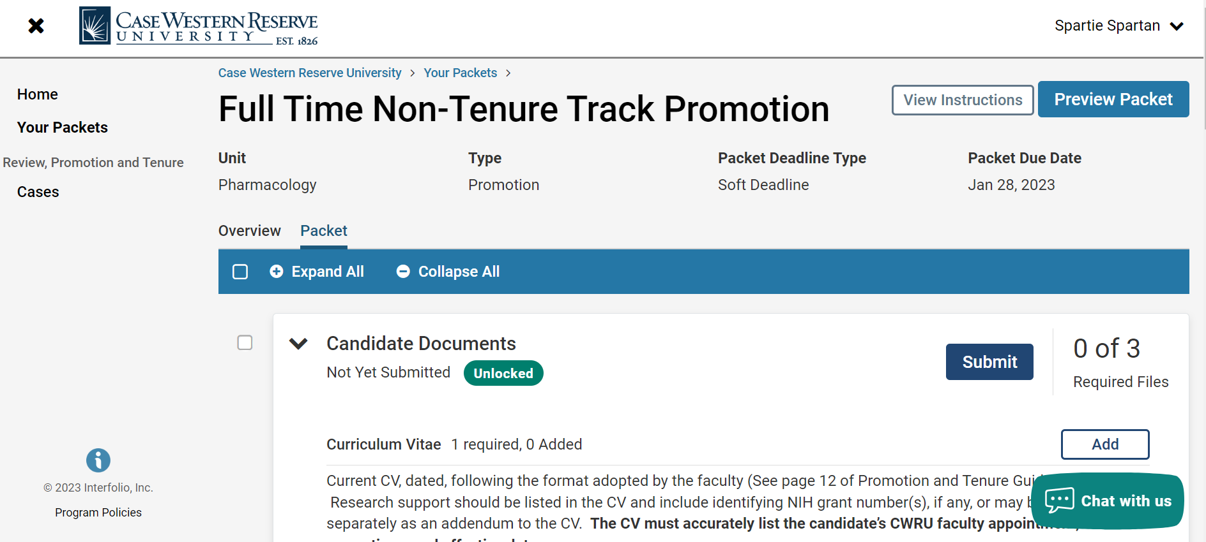
Click “Add” next to the document you would like to upload and select the file.
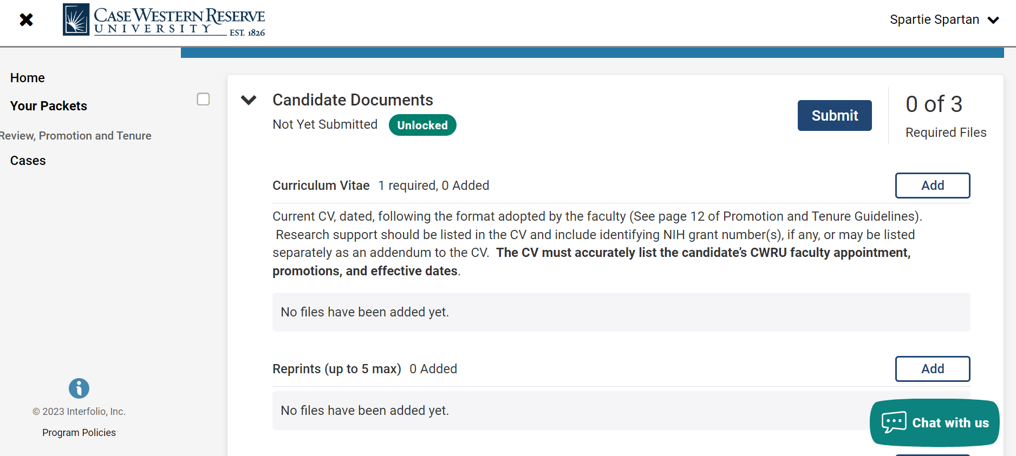
TIP: You can see your progress on the Overview tab. Please note that optional documents are automatically checked off.
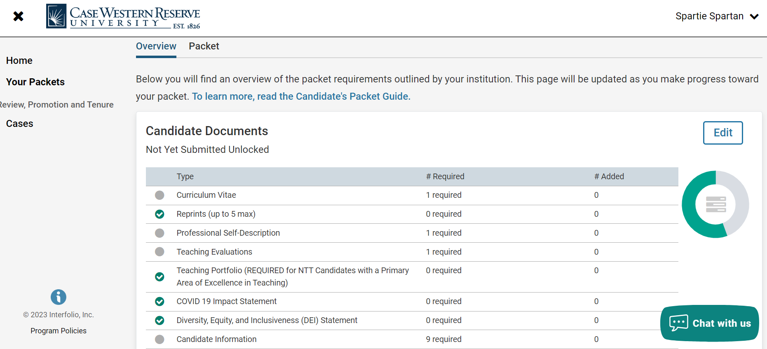

Step 3: Submit Documents
Once you have uploaded all required documents, you are ready to submit! Please Note: You must click the submit button to move your case forward for review. If you do not click submit, your application will not move forward.

TIP: Click the “Preview Packet” button in the top right corner to view all uploaded documents before submitting.
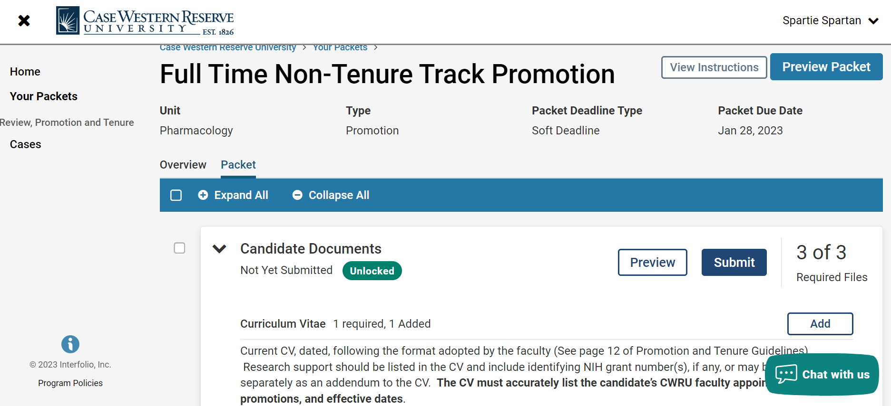
Click “Yes”.
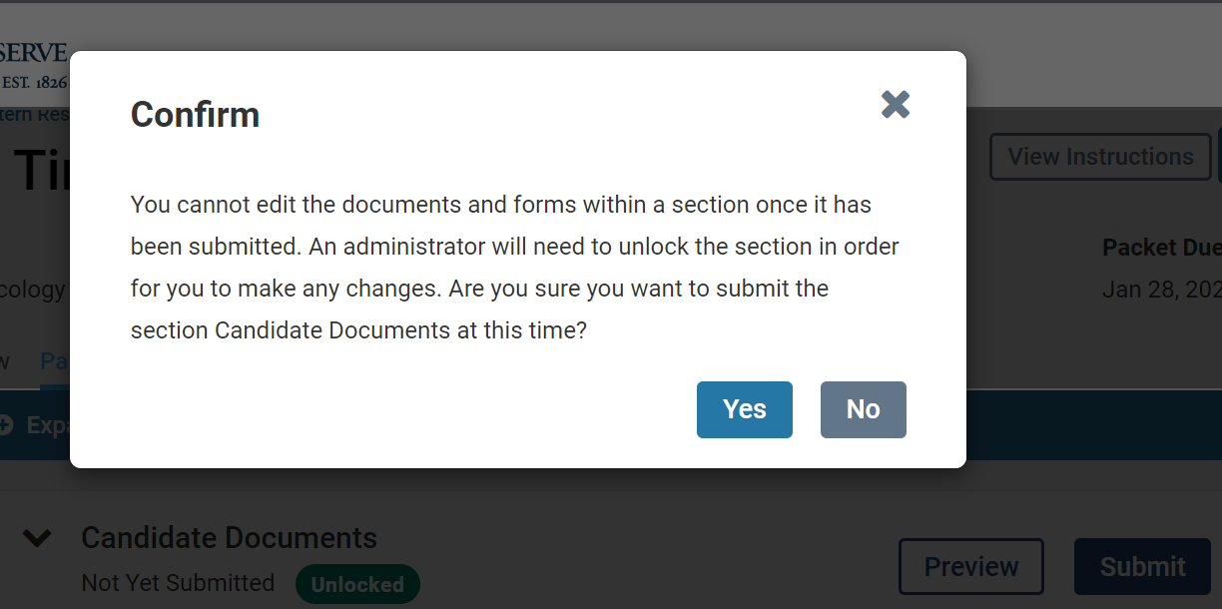

Once you click “Yes”, your packet will be officially submitted. Please contact your department administrator if you want to make any changes.

