Interfolio Job Aid for Department Admins

Interfolio Step 1: Initial Department Administrative Review
Once the promotion candidate uploads and submits all necessary documents, the case will move to the Initial Department Administrative Review step. The Chair and Admin will be notified that a task is ready to view.
Upon logging into Interfolio, click the Case Western Reserve University logo and then click the case you would like to open.
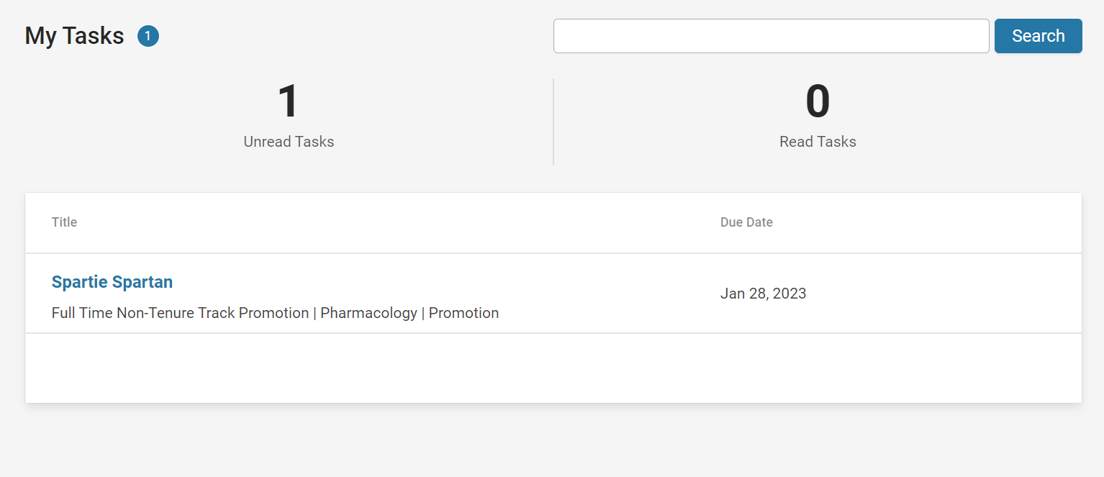
Next, click “Case Details” to read the instructions.
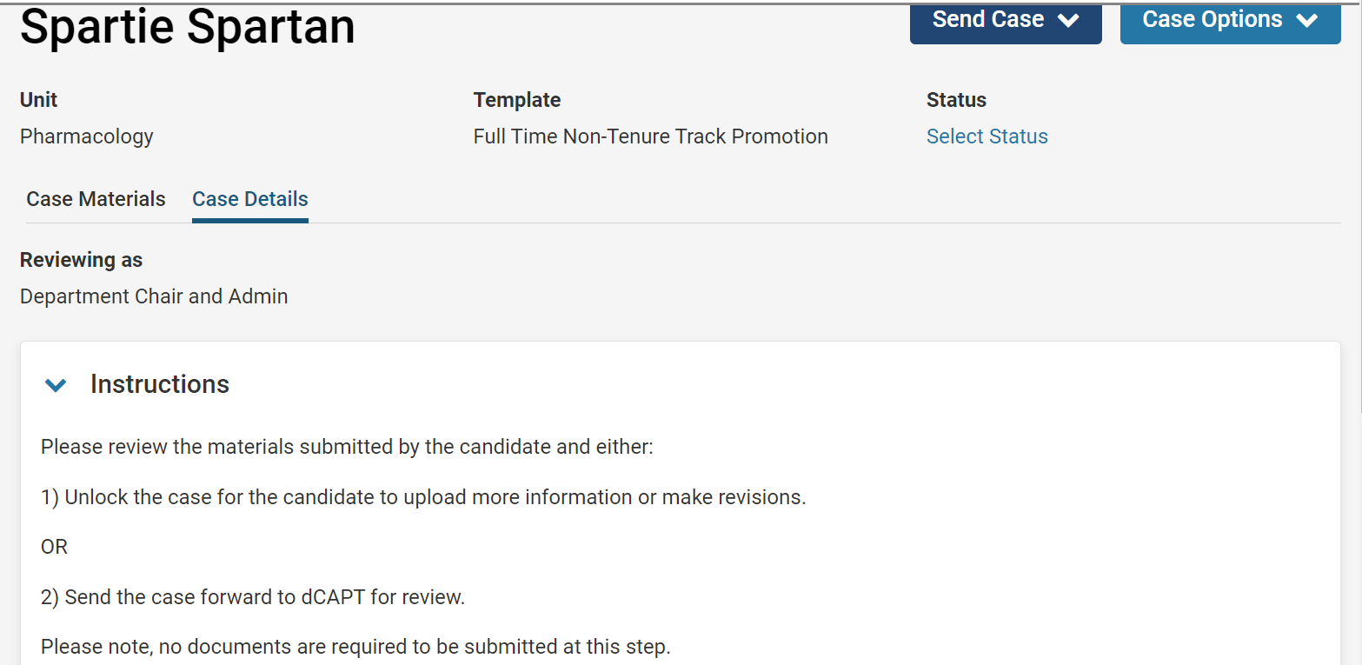
To view the documents submitted by the candidate, select “Case Materials” then either scroll down and click on each document individually or click the “Read Case” button.
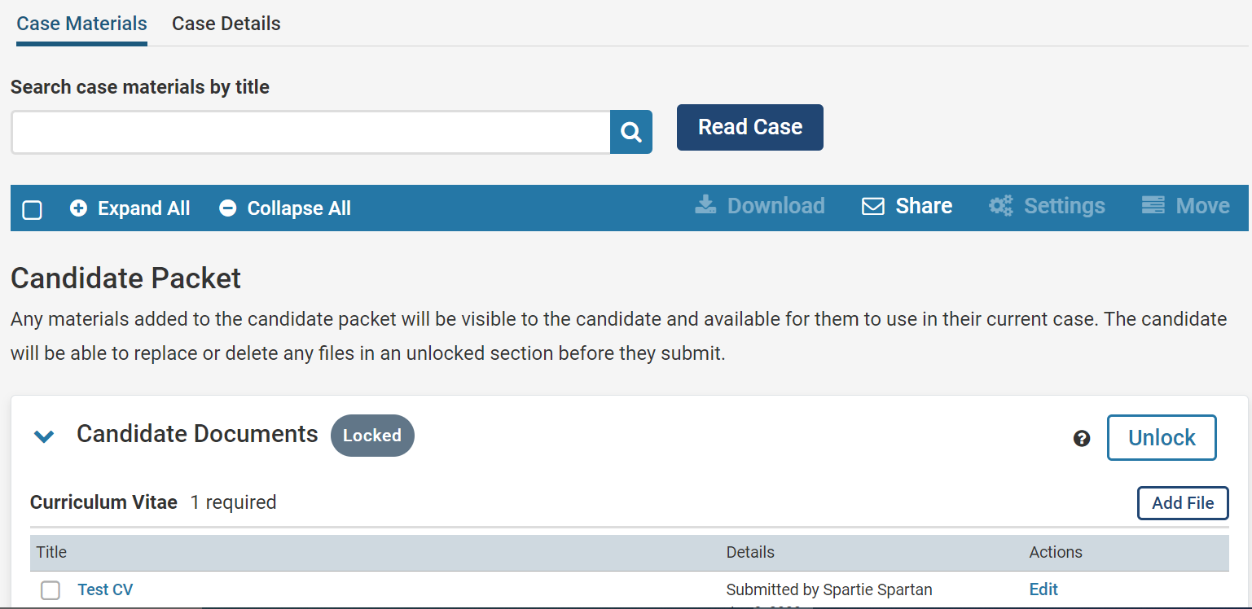

TIP: To download the packet’s documents, click “Read Case” and a download button should appear near the search bar in the right corner.

Once you have reviewed the documents and determined there are no errors, move the case forward to the next step (dCAPT Review).
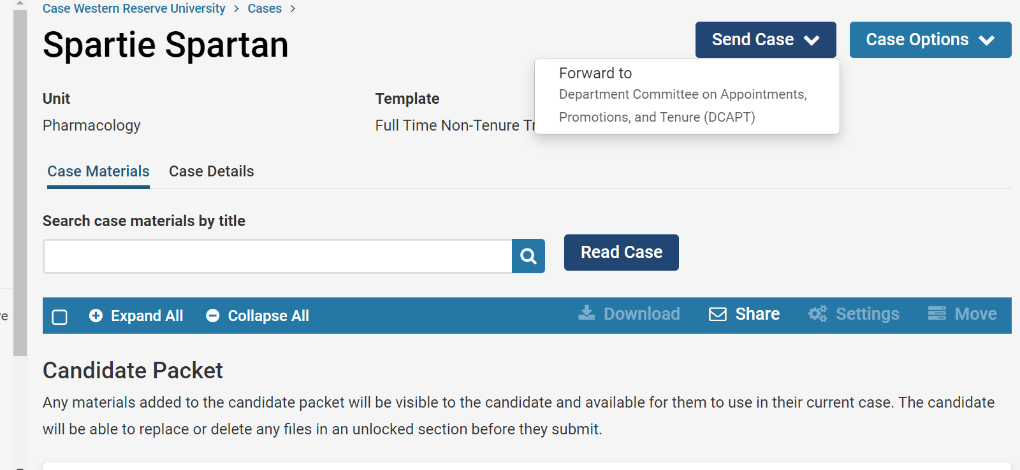
Please Note: You will have the option to send a message to all users gaining access (dCAPT members) when moving the case forward.

Interfolio Step 2: Department Committee on Appointments, Promotions, and Tenure (DCAPT)
At this step, only the Department Administrator can upload documents. The blue dot next “Case Details” means that there is a required document at this step. Click “Case Details” to read the Instructions and submit the required document.
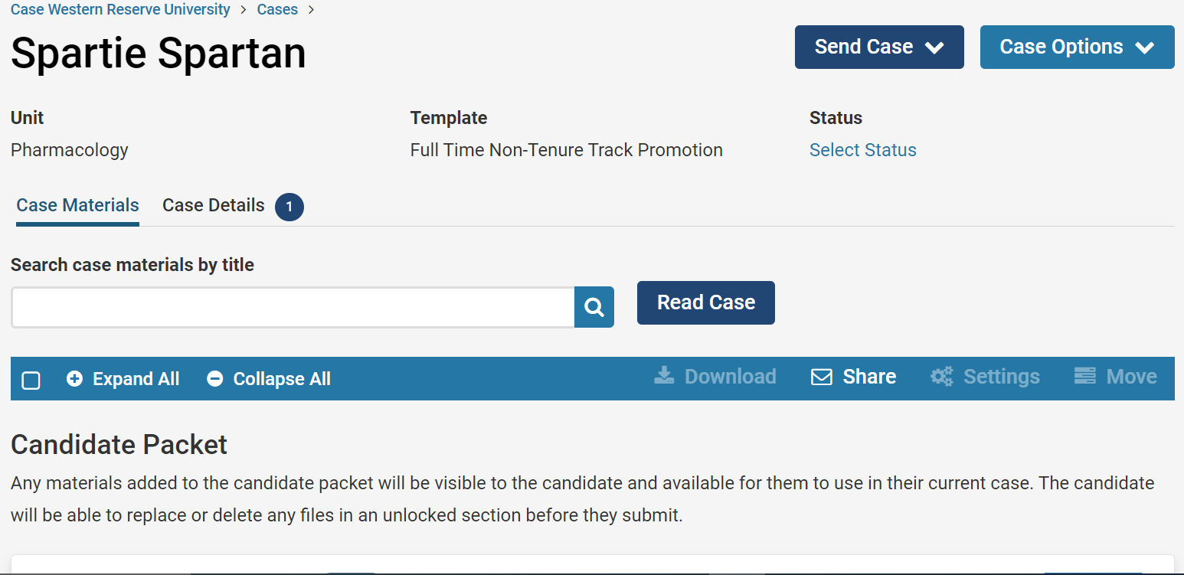
Click “Add” to upload the file. Please Note: You cannot move to the next step without uploading all required documents.
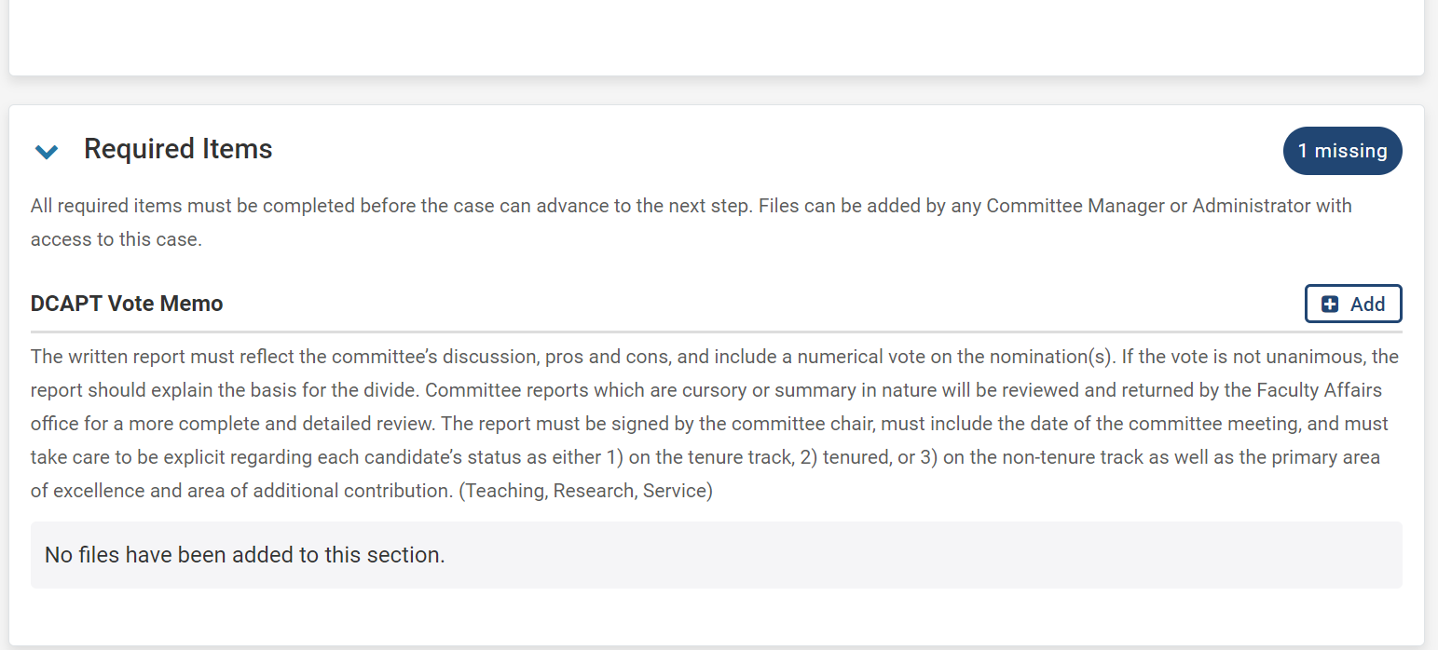
Please Note: Uploaded documents should be placed in the correct internal section. The dCAPT Vote Memo should be placed in dCAPT Review. (See Below)
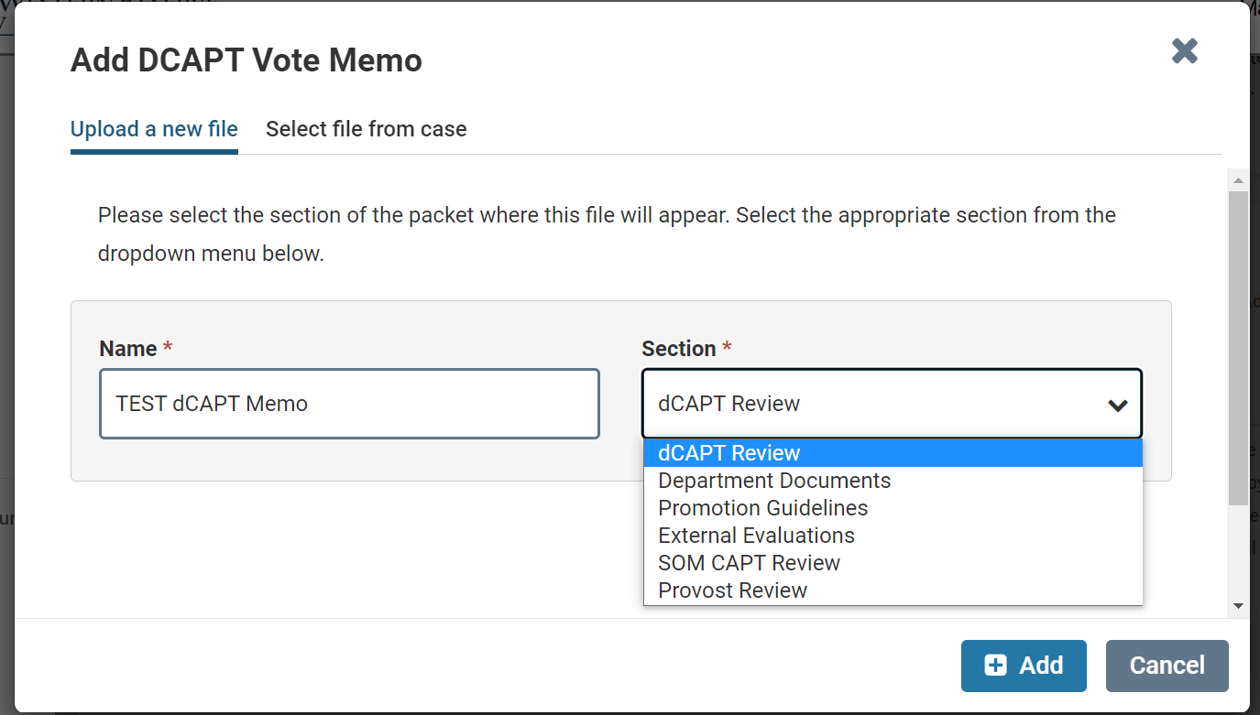
Once the vote memo has been added, send the case forward to the next step.
TIP: If an error was made at the previous step, you have the option to send the case backwards to that step again.
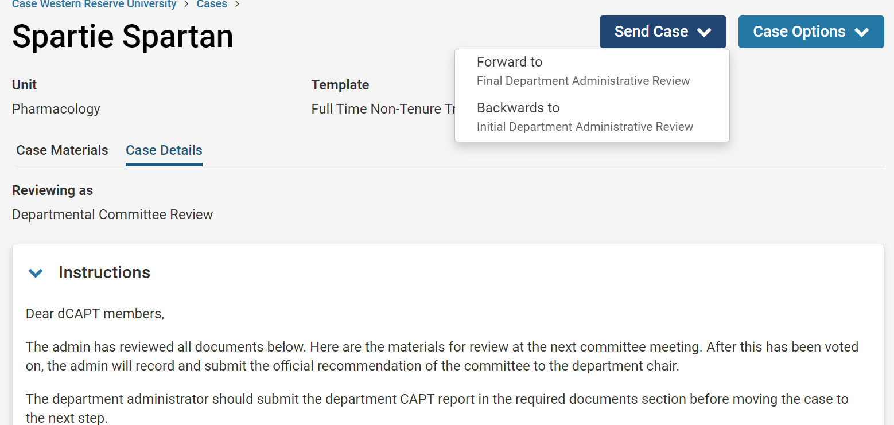

Interfolio Step 3: Final Department Administrative Review
At this step, only the Department Chair and Admin have access to upload documents and move the case forward. Just like the other steps, click “Case Details to view instructions and upload the required documents.
Unlike the other steps, this step has optional documents. The instructions detail that a letter of recommendation from the Division Chief or Secondary Department Chair is optional to add. To add these documents, click “Case Materials” and scroll past the candidate documents to see the “Internal Sections”. Use the dropdown arrow next to “Department Documents” and then click “Add File”.
Please Note: All documents (required and optional) uploaded at this step should be in “Department Documents”.
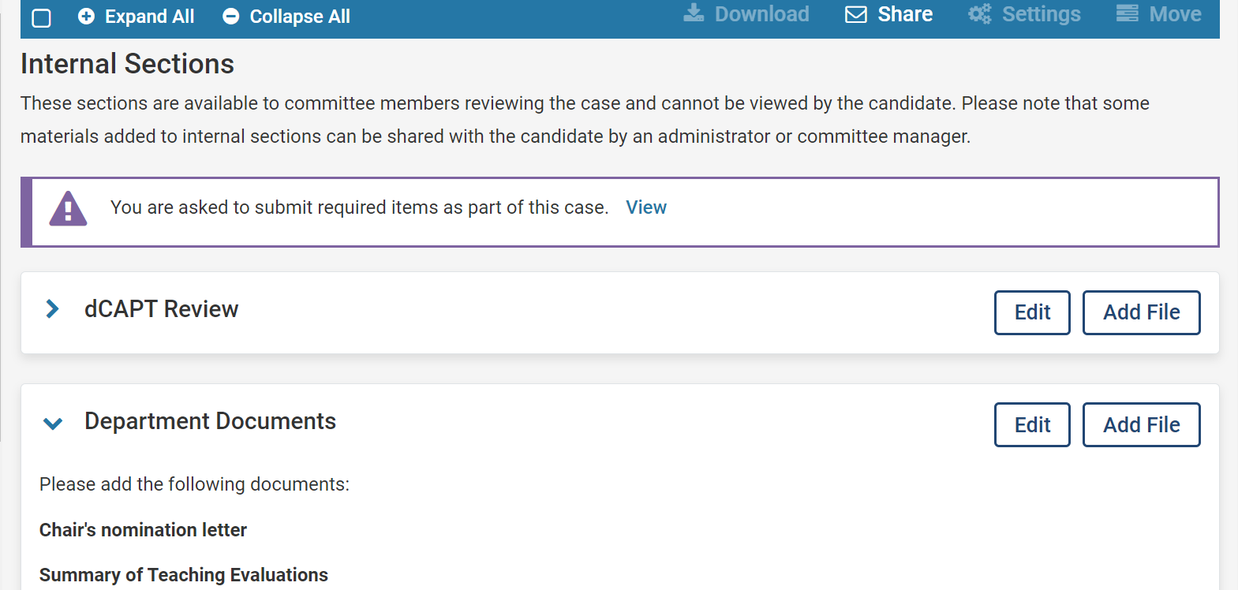
Once all documents have been uploaded, move the case forward to the Faculty Affairs office. This will be a submitted application!
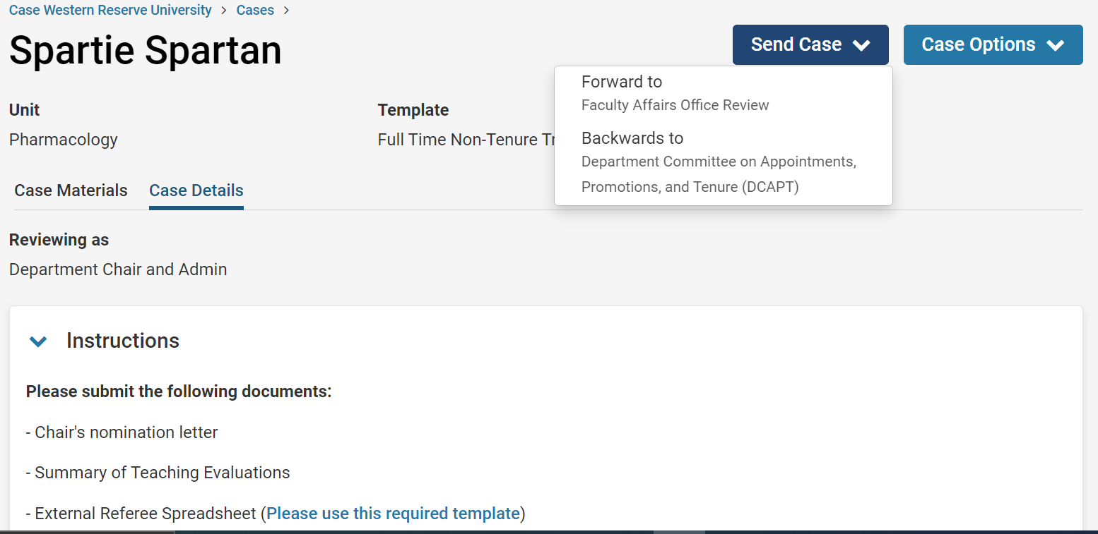
If you need to make any changes after submitting, please email the Faculty Affairs Office at facaffrs@case.edu

