The Triangle Lot is located at 11457 Mayfield Rd, Cleveland, OH 44106.
Individuals can use a CWRU ID, Parking Card or Guest Housing Card to enter this lot.
To enter, you will need to swipe/tap your card at the gate reader of surface Lot 75 which is a visitor parking lot. As a permit holder, you will not park in lot 75. Rather, you will drive across Lot 75 to gain access to Lot 78 which is actually a Garage known, or referred to, as Triangle Towers.
The garage has two entrances (please refer to the photos at the bottom of this page).
The entrance on the left-hand side of the garage (Lot 78) is used by Triangle Apartment tenants to gain entry into the garage.
The entrance on the right-hand side of the garage is used by Permit Holders to gain entry to the 2nd floor where parking is available. On the 2nd floor, permit holders will have to swipe/tap a CWRU ID, Parking Card, or Guest Housing Card at the gate reader to enter.
Permit holders must remember that entering Lot 78 is a 2-Tap-System.
1 Tap at Lot 75 allows them to traverse Lot 75 to gain entrance into Lot 78. Tap 2 occurs on the 2nd floor of Lot 78 inside of the garage-where permit holders can park anywhere beyond the second gate.
To exit lot 78 (the garage), you will need to tap/swipe your CWRU ID, Parking Card, or Guest Housing Card at the gate arm located on the 2nd floor by the ramp AS WELL AS the reader at the exit of the surface lot 75 visitor lot.
Swiping/tapping at both entrances and exits must be done even if the gates are raised. Missing a swipe/tap at any of the gate readers will cause an Anti-Passback violation. This type of violation will prevent you from being able to exit the lot until your parking access is reset.
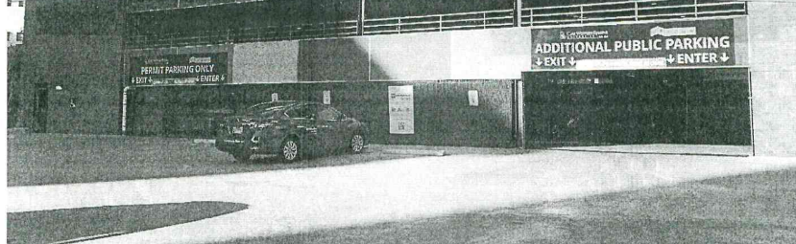
In the event you cannot enter or exit, please reach out to the department that distributed your card so it can be reset or call LAZ Parking 216-791-6226 after-hours to assist.
TRIANGLE APT. TENANTS ONLY
PERMIT HOLDERS PROCEED TO THE 2ND FLOOR

