After you have made the required changes to your requisition, you must manually approve it back through to purchasing. When a requisition is pushed back, self-approval does not apply when the Req is resubmitted.
In PeopleSoft, navigate to Main Menu>Manager Self-Service>Manage Approvals
Clear out the date fields and enter the requisition ID that needs to be sent to Purchasing. Click Search.
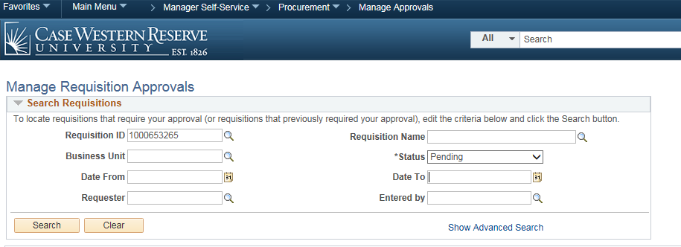

When the requisition comes up, click on the Requisition ID to open it up.
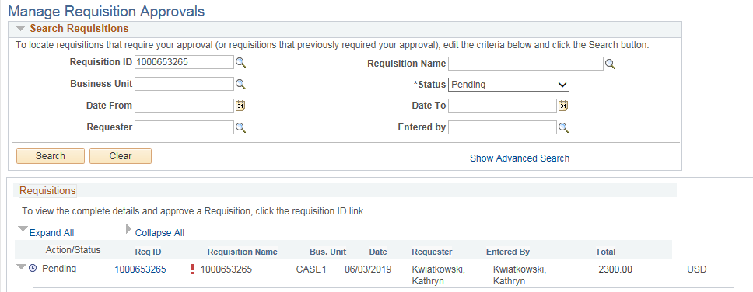

You will be taken to the requisition approval page. From here, you can see the requisition detail.
You may need to scroll down the page to see the approval button. You can also enter any comments you would like to send to the buyer.
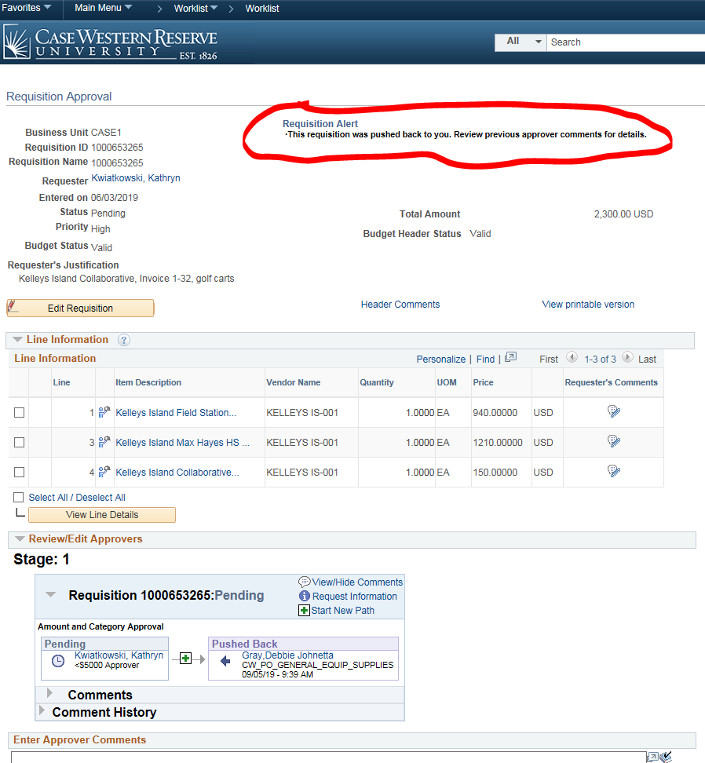

Click the Approve button to send it back to the buyer.
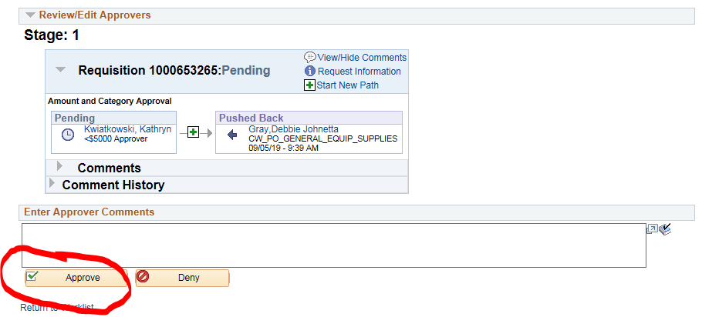
From here, you will get a confirmation page and be able to see that it is now pending with the buyer in Purchasing.
