Post-adoption resouce guide for families of cuyahoga county
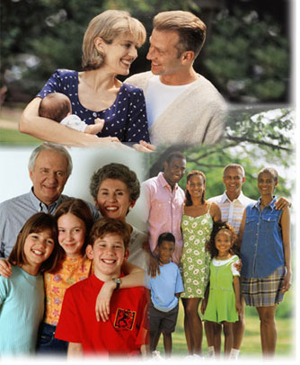

Spring, 2012

Respite Care

Respite care is short-term care given by another caregiver so that the child’s parent(s) can rest or take time off. This type of care was created to allow caregivers time away from administering care
to assist in lowering stress during times of crisis.

Providence House
http://www.provhouse.org/
The mission of Providence House is to “fight to end child abuse and neglect by protecting at-risk children, empowering families in crisis and building safe communities for every child”. This is a voluntary program that offers 24/7 emergency shelter for children 0-6 years old who are at risk of child abuse or neglect. While children are placed in their care professionals assess the child for developmental, and educational, medical and mental health needs. While the children are in a safe environment the staff works with parents to empower them to alleviate problems which put them in crisis.

ARCH National Respite Locator
http://archrespite.org/respitelocator
Respite care can be a very helpful tool for both the adoptive parent as well as the child(ren). Sometimes emotions can be tense and people just need to take a little break from each other. Due to some of the special needs that adopted children have it may be necessary to find someone trained to meet those specific needs. This website provides useful information regarding respite services by state. The consumer must recognize that this is an informational website and it is necessary for them to assume the responsibility of background checks and qualifications. There is also information regarding upcoming events and webinars.

Easter Seals Northern Ohio
http://noh.easterseals.com/site/PageServer?pagename=OHNE_homepage.
Easter Seals can provide either short- or long-term respite care for children with disabilities. Services can include bathing, dressing, and homemaker services.

Hattie Larlham
http://www.hattielarlham.org/
The Hattie Larlham organization is dedicated to improve the lives of children and adults who have a medical or developmental disability. They provide accredited respite care services can be provided at the Hattie Larlham Center for Children with Disabilities, in a certified provider’s home or the family home.

Cuyahoga County Department of Children and Family Services
http://cfs.cuyahogacounty.us/en-US/foster-adoptive-parents.aspx
Jane Edna Hunter Building
3955 Euclid Avenue
Cleveland, Ohio 44115
(216) 431-4500 / (216) 432-5047 (fax)

And

Adoption Network Cleveland
http://www.adoptionnetwork.org/

CCDCFS or Adoption Network Cleveland provide respite care, however they can assist you in linking with other adoptive parents through clusters, meetings, and other events where connections may be made that could lead to respite care.

Financial Assistance

Ohio Department Job and Family Services
http://jfs.ohio.gov/sacwis/docs/workflow/PASSS_02.pdf
Navigating through the bureaucracy of government forms and procedures can be confusing. This web address provides a flow chart on accessing funds through PASSS (Post Adoption Special Services Subsidy).

Cuyahoga County Department of Children and Family Services
http://cfs.cuyahogacounty.us/en-US/foster-adoptive-parents.aspx
Jane Edna Hunter Building
3955 Euclid Avenue
Cleveland, Ohio 44115
(216) 431-4500 / (216) 432-5047 (fax)

CCDCFS can assist families in accessing additional financial assistance for adoptive families in crisis through the Post Adoption Special Services Subsidy, State Adoption Maintenance Subsidy, Cuyahoga County Special Services, and Non-Recurring Adoption Expenses. This assistance may apply to all children whether they were adopted through a government or private agency. It is not necessary that the adoption occurred in Cuyahoga County. Please note that certain programs may not be funded at all times.

Cuyahoga County Employment and Family Services
http://employment.cuyahogacounty.us/
Families may be eligible for additional financial assistance through cash benefits, food assistance, medical coverage, or emergency funds. Income eligibility will apply to many of these programs.

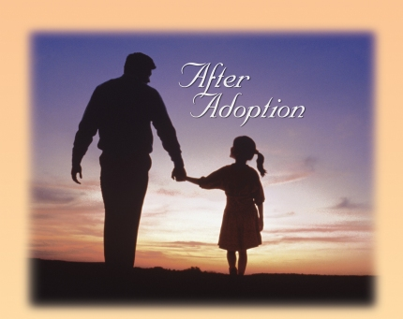

Crisis intervention/
mental health/Educatonal Services

Please note – the list of agencies provided in this section does not cover all services offered in Cuyahoga County. However, the specific agencies listed above are agencies that either have adoption services or have experience in working with adopted children and families.

Berea Children’s Home & Family Services
http://www.bchfs.org
This is a multi-service agency providing mental health services to youth in the community. They have counseling services specifically for adoptive families. They also provide crisis stabilization, residential placements, early childhood mental health, outpatient, family and group counseling, school-based counseling and support services, and the Snow School Day Program.

Bellefaire JCB
http://www.bellefairejcb.org
This agency provides a variety of behavioral health, education and prevention services for children and their families. They provide both in-patient and out-patient counseling services as well as on-staff psychiatrists. They have therapists who have experience working with both adoptive and birth families. They also have two social events each year for adoptive families to get together in a fun atmosphere.

Beech Brook
http://www.beechbrook.org
Beech Brook offers a variety of services for adoptive families including residential services, day treatment, outpatient counseling, school-based services, and staff that are trained to deal with the traumatic experiences many children experienced prior to their adoption.

First Call for Help
http://www.211cleveland.org/
First Call for Help (aka as 2-1-1) is a free community service similar to the Yellow Pages you can use to get information about social, health and government resources. The service is available 365 days a year, 24 hours a day and is accessible through either their website or calling 2-1-1.

Applewood
http://www.applewoodcenters.org
This agency provides school-based counseling, group counseling, psychiatry, and residential services. A specialized service they offer is Multisystemic Therapy (MST). MST is an intensive therapeutic and case management type of service for youth with serious behavioral problems and who are involved or at risk of involvement with the juvenile court system.

Center for Families and Children
http://www.c4fc.org
CFC offers mental/behavioral health services for all ages of children. They also have an early education program beginning at birth.

Miscellaneous

Adoption Network Cleveland
http://www.adoptionnetwork.org/
Adoption Network Cleveland provides services for all persons touched by adoption, i.e., birth families, adoptive families, and adoptees. Services include education/information, mentoring, advocacy, parenting, youth services, consulting and search and reunion. They hold monthly meetings and other various events.

U.S. Department of Health and Human Services
Child Welfare Information Gateway
http://www.childwelfare.gov/pubs/f_postadoption.cfm
This informative website features a factsheet which provides information regarding post-adoption services which include identifying the most common issues families face, milestones and developmental stages that may trigger problems or concerns, types of available post-adoption support, finding post-adoption services, how to pay for post-adoption services, and resource for adoptive families. The website allows for documents to be downloaded and includes numerous links for more detailed information on topics.

North American Council on Adoptable Children
http://www.nacac.org/
This website was designed to help children who are awaiting adoption, as well as the children and families after adoption. The website has information regarding adoption subsidy, parent groups, respite, how to advocate for post-adoptive services, major policy topics affecting adoption, and information regarding upcoming conferences and training.

We witness a miracle every time a child enters into life.
But those who make their journey home across time & miles,
growing within the hearts of those who wait to love them,
are carried on the wings of destiny and placed among us
by God's very own hands.
--- Kristi Larson
(http://www.karensadoptionlinks.com/inspirat.html)

