**Birth Parents Supports**

The decision to place a child for adoption is extremely difficult. It is a decision that has far reaching effects for all members of the adoption constellation. When a parent is unable to parent the child they gave birth to for whatever reason a void is created that very little can fill. There are many emotions that biological parents face as a result of the relinquishment of their child. There are many things to consider as you make the choice to place your child for adoption. The following are resources that provide information around some of the issues facing birth parents as well as information about what to expect during the adoption process. The list presents the link and some information about what each website has to offer.



<http://www.adoptionnetwork.org/birthparents-and-families.aspx>

Adoption Network Cleveland believes in helping and providing support to everyone touched by adoption adoptees, birthparents, adoptive parents, foster youth and alumni, foster parents and professionals. There is a section of the site devoted to birth families with a help line number as well as information about support groups and search assistance.

<http://www.childwelfare.gov/pubs/f_impact/>

The Child Welfare Information Gateway is a service of the Children's Bureau, Administration for Children and Families, U.S. Department of Health and Human Services. It provides a link to information regarding issues in child welfare that effect safety, permanency, adoption, child abuse and neglect. The sight has a link to information for birthparents The Responses to Adoption Placement

C:\Users\zamc518\AppData\Local\Microsoft\Windows\Temporary Internet Files\Content.IE5\G86RU2EJ\MC900045244[1].wmf

<http://www.cubirthparents.org/home/>

Concerned United Birthparents is a national organization focused on birth parents. This agency is concerned with the education of as many people as possible about the realities of adoption, family separation and reunion. While they do not provide search assistance their goal is to emotionally support those in the process of search and reunion as well as working towards adoption reform.



<http://www.openadoptioninsight.org/html/birthparents.html>

Insight: Open Adoption Resources and Supports is a non –profit agency that is committed to providing the most current accurate and thoughtful information on open adoptions. They provide resources and information for birthparents, adopted parents and adoptees. This is a good site for anyone thinking of placing their child for adoption who is looking for information about open adoptions. The website has some very thoughtful information about roles of each member of the adoption constellation.



<http://www.adopting.org/impact.html>

Adopting.Org is a website for birth parents and adopting parents. They provide information for birth parents considering placing a child for adoptions as well as birth family support and organizations. There is a message board for old and new birth parents to talk. They also have an adoption reunion resource section.



<http://www.adopting.org/adoptions/birthfathers-first-fathers.html>

This link is to a site on the Adopting.org website that is dedicated to the unique experiences of birth fathers. This site reminds birth fathers that they have rights and responsibilities in an adoption plan. It helps them understand what to expect in adoption proceedings and what to do if they choose to parent. There is information and resources for and about birth fathers as well as information about support groups and discussion boards.



<http://birthparents.adoptionblogs.com/>

Adoption.com has a link on their website to Birth-first parent’s page. This is a blog site for birth parents to share stories, feelings and experiences



<http://www.adoptionbygentlecare.org/home/services3>

Adoption by Gentle Care is a site for birth and adoptive parents that help facilitate open adoptions. They will help create an individualized adoption plan that is in the best interest of all the member of the adoption constellation. They provide physical and emotional support for birth mothers as they go thru this process

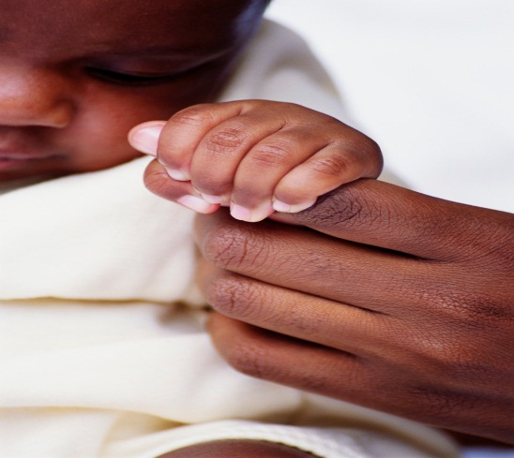

<http://www.birthmotherresources.com/>

This website, Birth Mother Resources, was created to help the mother learn and understand more about her pregnancy, about the child she will deliver or has already given birth to, and about resources that can help her raise her child or help her to place her child with an adoptive family. It discusses a variety of options like open vs. closed adoption, placement with relatives and private vs. public agencies.

<http://www.adoptioninstitute.org/research/2006_11_birthparent_wellbeing.php>

The Adoption Institute website is committed to safe guarding the rights and wellbeing of birth parents in the adoption process. This site has more research around topics salient to different areas of adoption. This is an excellent website for those wanting to become involved in the area of adoption at a legislative level. The website has gathered significant research information on the adoption process and practices.



<http://www.adoptionservices.org/birth_mother/birth_mother_rights.htm>

Adoption services website provides support and information for birth parents to help them understand their rights in the adoption process. It has a section that allows you access information about your rights state by state. There is information to help the mother while she is expecting and after. There is also a special section dedicated to birth fathers. The site also provides resources and information for parents that decide to keep their children.

Created By:

Lisa Stevens Cutner

Case Western University

Sass 505 Adoptions: Practice and Policy