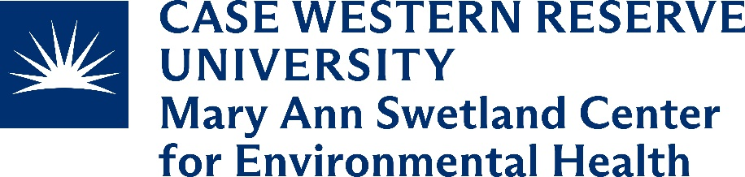

The Mary Ann Swetland Center for Environmental Health within the Department of Population and Quantitative Health Science at Case Western Reserve University School of Medicine is pleased to share that we are hiring up to five SNAP-Ed Program Assistants by the end of 2024 to serve Cuyahoga County.
Program Assistants will provide direct nutrition and physical activity educational programming (e.g., teaching standardized classes) and Policy, Systems, and Environmental (PSE) interventions (e.g. school gardens, choice food pantries, promoting SNAP at farmers markets) with local, community-based partners in areas of high food insecurity throughout Cuyahoga County. The educational programming and PSE interventions will serve SNAP-eligible individuals of various demographics in a variety of community settings and will use USDA approved, standardized curriculum and evidence-based PSE approaches to improve access to nutritious food and physical activity opportunities.
Program Assistants will consult with the SNAP-Ed Manager and community partners to implement SNAP-Ed throughout Cuyahoga County. They will assist in developing and maintaining key relationships with community-based and community-serving organizations. In addition, Program Assistants will collect and report metrics from participants within direct education and PSE interventions using standardized forms.
Successful candidates are required to have a high school education in addition to 5 to 8 years of related experience OR an associates degree with 1 year of experience OR a bachelors degree with 6 months of experience. Degrees should be related to public health, community health, nutrition and/or education. The candidate will have experience teaching in group settings, experience with diverse populations, ability to work with a high degree of independence, strong communication skills, and the ability to work well in a team. Reliable transportation and a valid Driver’s License are required for this position as it involves frequent travel to programming sites throughout the county and some travel throughout the State for training and professional development. Program Assistants must uphold the values of the Swetland Center including a commitment to racial justice, collaboration, community engagement, inclusivity, and innovation.

For more information about the Swetland Center: https://case.edu/swetland/.
To learn more and apply: https://case.edu/swetland/community/snap-ed
Case Western Reserve University is an Equal Opportunity Employer encouraging excellence through diversity. Qualified women and minority candidates are encouraged to apply.

Here are some of the benefits and why it is so great to work at CWRU and the Swetland Center!
- Flexible hours and generous paid time off for holidays and personal time
- Educational benefits for employees and dependents
- Professional development opportunities
- Access to CWRU’s Campus Organizations and Resources
- CWRU benefit program
- Perks and Extras of CWRU staff

