State of the Science Update || Public Meeting and Open House

July 23, 2024 || 4:00pm – 7:00pm
East Palestine High School Gymnasium
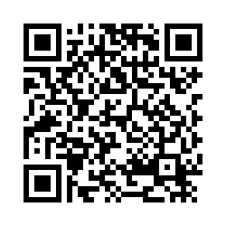
360 W Grant St, East Palestine, OH 44413

Free and Open to the Public || Refreshments Provided || RSVP HERE or Scan the QR Code

Our Goals
- Hear what we've learned by analyzing soil and sediment data collected after the train derailment in East Palestine.
- Meet researchers funded by NIH doing studies in response to the derailment.
- Brainstorm ideas for future research that aligns with community interests.

Agenda
4-5pm Open House: Meet and Greet Researchers at Information Tables
5-6pm Public Presentation on Findings and New Research Initiatives
- Review findings from data collected following the train derailment.
- Learn about newly funded studies focused on assessing health impacts and community healing.
- Open Q/A about future research opportunities.
6-7pm Open House: Meet and Greet Researchers at Information Tables

What did people say about our last State of the Science Update?
“This was one of the best community interactions in response to the derailment.”
“This was a place to get an unbiased review of the data.”
“The fact that this meeting happened is proof there is hope.”

Who are we? The Ohio/Pennsylvania (OH/PA) University Research Consortium is made up of about two dozen researchers from seven universities, the East Palestine health community, and responding agencies. Consortium members are from various academic disciplines, bringing relevant expertise and research experience. The consortium is organized by researchers from Case Western Reserve University, The Ohio State University, Kent State University, and University of Pittsburgh

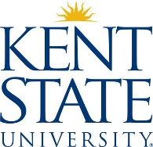
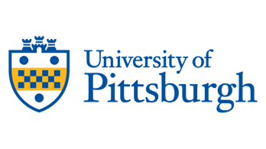
What is the goal of the OH/PA University Research Consortium? Our goal is to provide accurate, data-driven information to the East Palestine community. We organized and assessed data from various sources as an independent group after the February 2023 train derailment. These sources included response agencies, supporting institutes, and other researchers. We developed objective recommendations and will suggest further research to aid the community’s efforts in public health and environmental monitoring.

