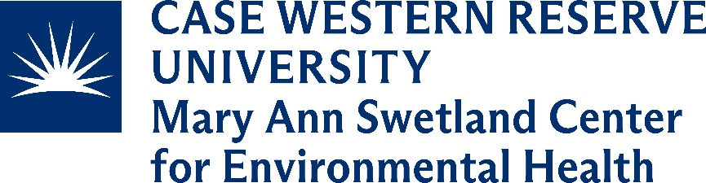
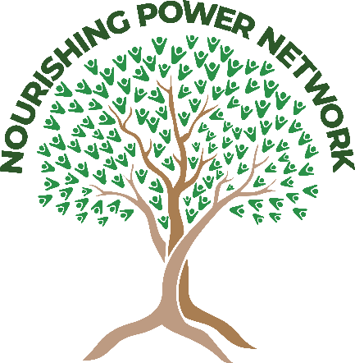
Request for Proposals
Telling the Story of the Nourishing Power Network
Term of Service: August 1, 2024 – January 31, 2025 || Maximum Bid: $15,000

Background
The mission of the Mary Ann Swetland Center for Environmental Health (https://case.edu/swetland) at Case Western Reserve University, School of Medicine is to study the complex interplay between environmental drivers and population health outcomes. The center places special emphasis on community-engaged approaches that address the role of structural racism in creating and sustaining environmental health inequities and seeks to translate these findings into policies, practices, and relationships that promote community and population health equity. Food systems and health equity is a priority research area of the Swetland Center, including how power can be transferred and leveraged to advance food justice work led by the community that results in holistic health in body, mind, and spirit.
In 2022, the Swetland Center began a community engaged participatory action research project called the Nourishing Power Network (NPN). The NPN consists of 4 main elements: a community led Advisory Council, a funding arm called the Nutrition Equity Fund, an idea incubator entitled the Nourishing Power Fellowship, and a broad networking component. Leveraging these 4 components, the study seeks to test ways to transform the food system by bridging community power with organizations power to spark and expand food justice initiatives led by the community. The end goal is to root and grow a local food system that promotes freedom, hope and dignity in food traditions resulting in holistic health for Black, Latino/a/x, Asian, and Indigenous communities.

Request
The Swetland Center is seeking a firm to aid in telling of the Nourishing Power Network story for dissemination to three key audiences: Black, Latino/a/x, Asian, and Indigenous communities in Greater Cleveland, local decision makers (e.g., policy makers, government officials), and funders (local, state, national). The work must be completed during a 6-month timeframe from August 1, 2024 – January 31, 2025. The following deliverables will be expected as a part of this agreement.

Requested Deliverables
Deliverable 1  Estimated Cost: $2,000  Completed by  October 1, 2024 | Support members of the Nourishing Power Network in identifying what story/stories they would like to tell related to the impacts of the Nourishing Power Network at the following levels: Individual, Interpersonal/relational, Institutional, Systemic.
Tasks to support deliverable 1:
  - Attend a kickoff meeting with the study’s leadership team (1.5 hours) before August 5, 2024.
  - Review the structure and function of the Nourishing Power Network based on materials provided by the study’s leadership team and shared via Basecamp. All collateral for the study, including logos, existing video and photography, will be shared with the firm via Basecamp.
  - Facilitate a storytelling and narrative development interaction session at a community meeting with Nourishing Power Network partners on Tuesday, August 13th from 9a-11a in Midtown, Cleveland.
  - Summarize potential stories based on feedback provided related to Deliverable 1.
Deliverable 2  Estimated Cost: $1,500  Completed by  October 1, 2024 | Develop a communications plan for telling the story of Nourishing Power Network to reach key partner audiences and key levels of impact.  - Target Audiences: Black, Latino/a/x, Asian, and Indigenous communities in Greater Cleveland, local decision makers (e.g., policy makers, government officials), and funders (local, state, national)  - Levels of Impact: Individual, Interpersonal/relational, Institutional, Systemic.
Tasks to support deliverable 2:
  - Draft a plan to disseminate the story of the Nourishing Power Network using visual (i.e. short videos, graphics) and written media (brief reports, one-pagers) to reach the target audiences and show impact across the four levels. The plan should include examples of what media products, effective dissemination strategies (including the Nourishing Power Network social media channels), and timeline needed for development and distribution.
  - Develop a budget for the best use of the funding resources to support the dissemination plan.
  - Present dissemination plan to the study’s leadership team by October 1, 2024.
Deliverable 3  Estimated Cost: $10,000  Completed by  January 31, 2025 | Develop visual and written media products for the dissemination of the story of Nourishing Power Network based on decisions made through Deliverable 2.
Tasks to support deliverable 3:
  - Create at least 4 unique products (at least 2 visual/video and 2 written) capturing the story of Nourishing Power Network for distribution by the Swetland Center during and after this agreement period.
  - Conduct at least 1 feedback session with Nourishing Power Network partners on the products to guide refinement by January 15, 2025.
  - Provide all collateral for the products, including templates, branding materials, etc.
Deliverable 4  Estimated Cost: $1,500  Completed by  January 31, 2025 | Develop a dissemination plan that spans at least 60 days to share the created products with the goal of reaching the targeted audiences listed in Deliverable 2. This plan will be implemented by the Swetland Center and the Nourishing Power Network.
Tasks to support deliverable 4:
  - Develop a plan to guide dissemination, including calendar, recommended content, and information about specific audiences (i.e., emails, handles, etc.).
  - Identify metrics to assess the reach of the products based on the dissemination plan (i.e., google analytics or other metrics).
  - Create linkages to key publication audiences locally to support uptake of the storytelling products within local media (i.e., newspapers, TV, radio, etc.).
  - Present the dissemination plan to the study’s leadership team by January 15, 2025.

Proposal Details for Consideration (to be completed by vendor)
- Company Overview
- Service Offerings
- Development Lifecycle Philosophy including strategies to stay on time and on budget
- Case Studies of Similar Work
- Alignment between firm and the mission and vision of the Swetland Cetner and Nourishing Power Network
- Professional Services References (at least 2)
- Proposal
  - Solution Overview
  - Project Scope
  - Project Team including roles and responsibilities
  - Project Timeline including confirmation that deliverables will be met on time
  - Pricing Model including breakdown by each deliverable

Additional Details
- Contractor will be required to register as a vendor with CWRU and follow CWRU policies for vendor reimbursement.
  - Have you ever been a contractor with CWRU? ____ Yes ____ No
Estimated Timeline:
August 2024 to January 2025

Total Budget for All Deliverables:
Up to $15,000 (Estimated cost must include a quote per item of RFP, including estimated labor).

Submit information by July 10th at 11:59pm EST to mxp800@case.edu.
Please reach out to mxp800@case.edu if you would like to set up an initial consultation.

